Dashboard Chosen: LinkedIn Top Skills 2016

**Insight 1:**

What is the global average rank for SEO/SEM Marketing?

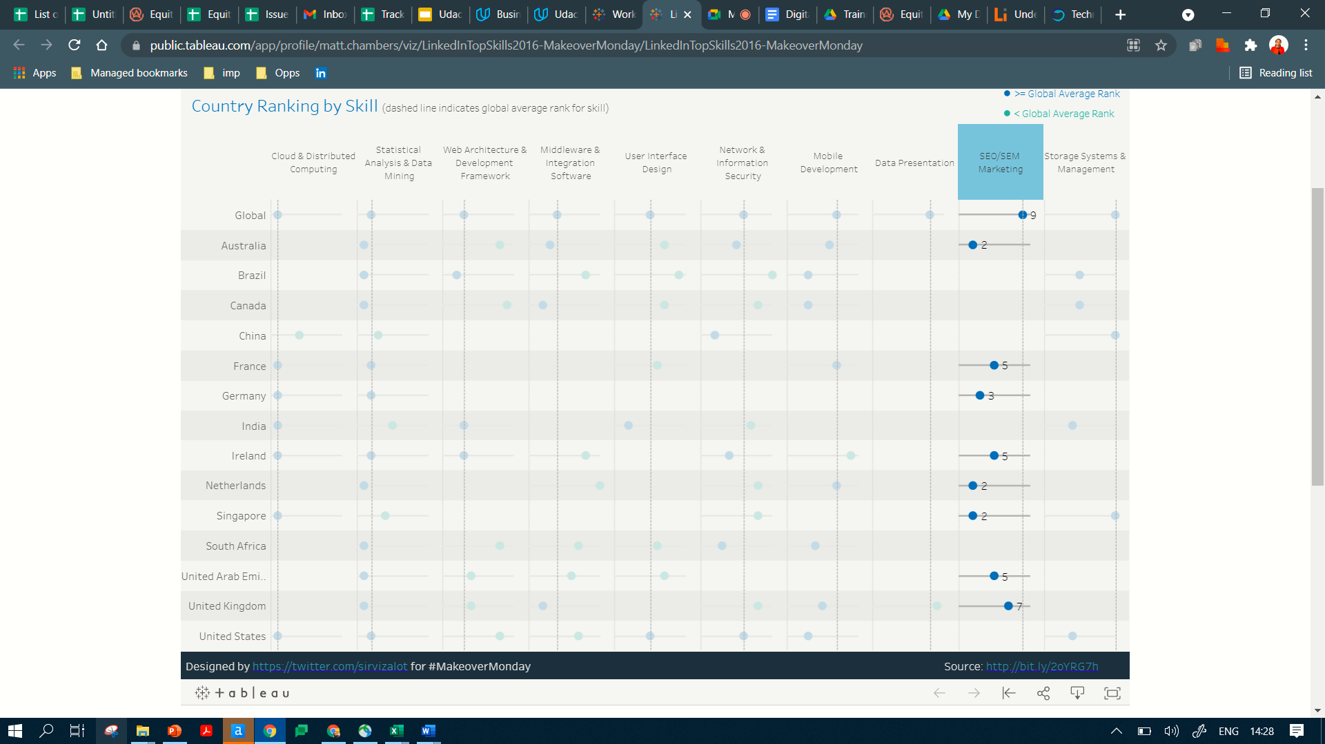

The global average rank for SEO/SEM Marketing is 9.

I found this by clicking on SEO/SEM Marketing, on the dashboard, the checking the row which represents Global, this is the first row.

**Insight 2:**

In how many countries is the User Interface Design ranking, below the global average rank?

The average rank for User Interface Design is greater than the global average rank in only one country,that is India.

The Key above shows that green markers indicate that the average ranking for that country and skill, is lesser than the Global average rank,while the blue markers show that the average ranking for that country and skill is greater than or equal to the Global average rank.

I clicked on the User Interface Design skill, and identified the Global average rank, which is 5.I checked for the countries with blue markers, i.e. whose ranking is greater than or equal to the Global average.

I found two countries. India and United states. Of the two, United States ranking is 5, which is equal to the Global average rank. India has a raking of 2, which is greater than the Global Average Rank

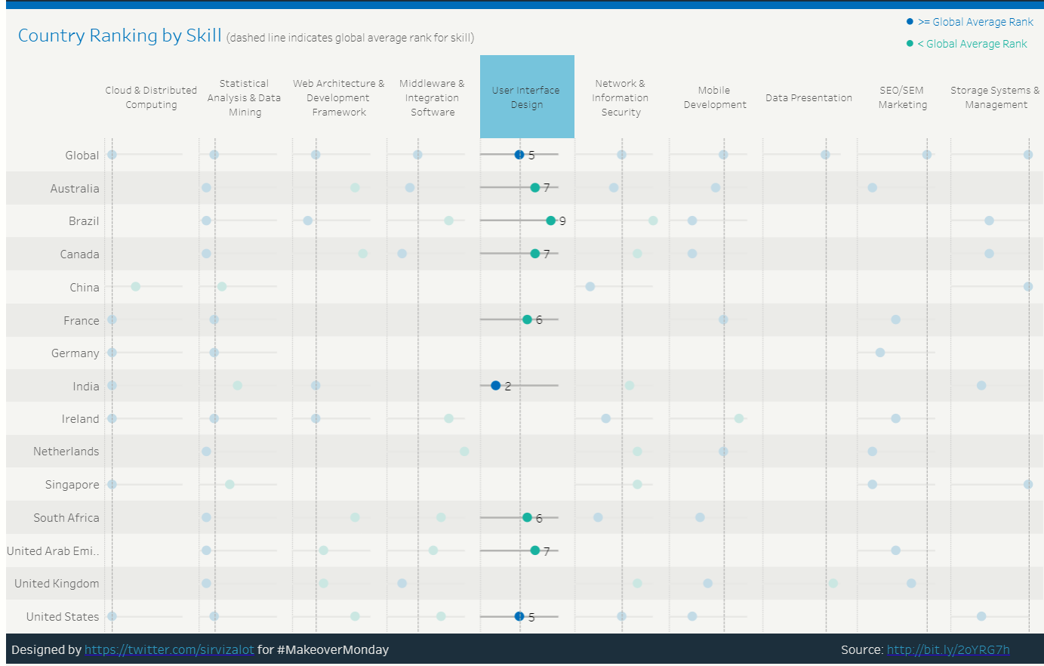

**Insight 3 :**

How many skills in United Kingdom, are below the global average rank, for their respective category?

**Global Ranking**

**United Kingdom Ranking**

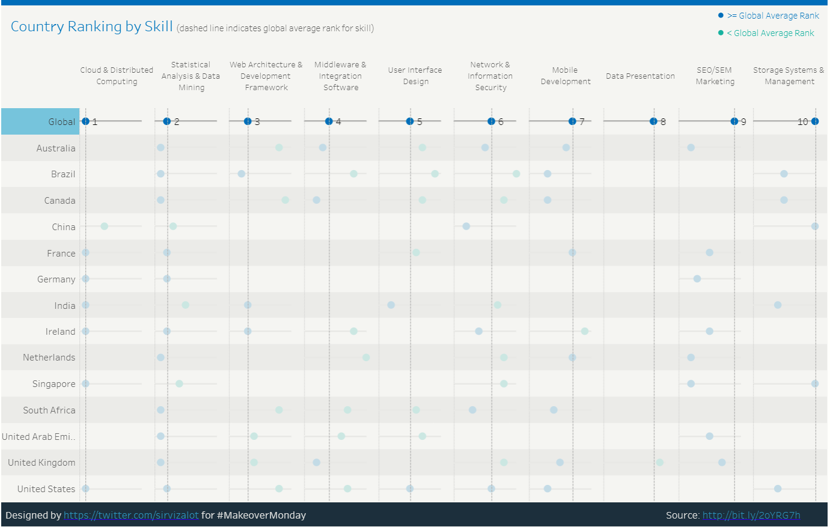

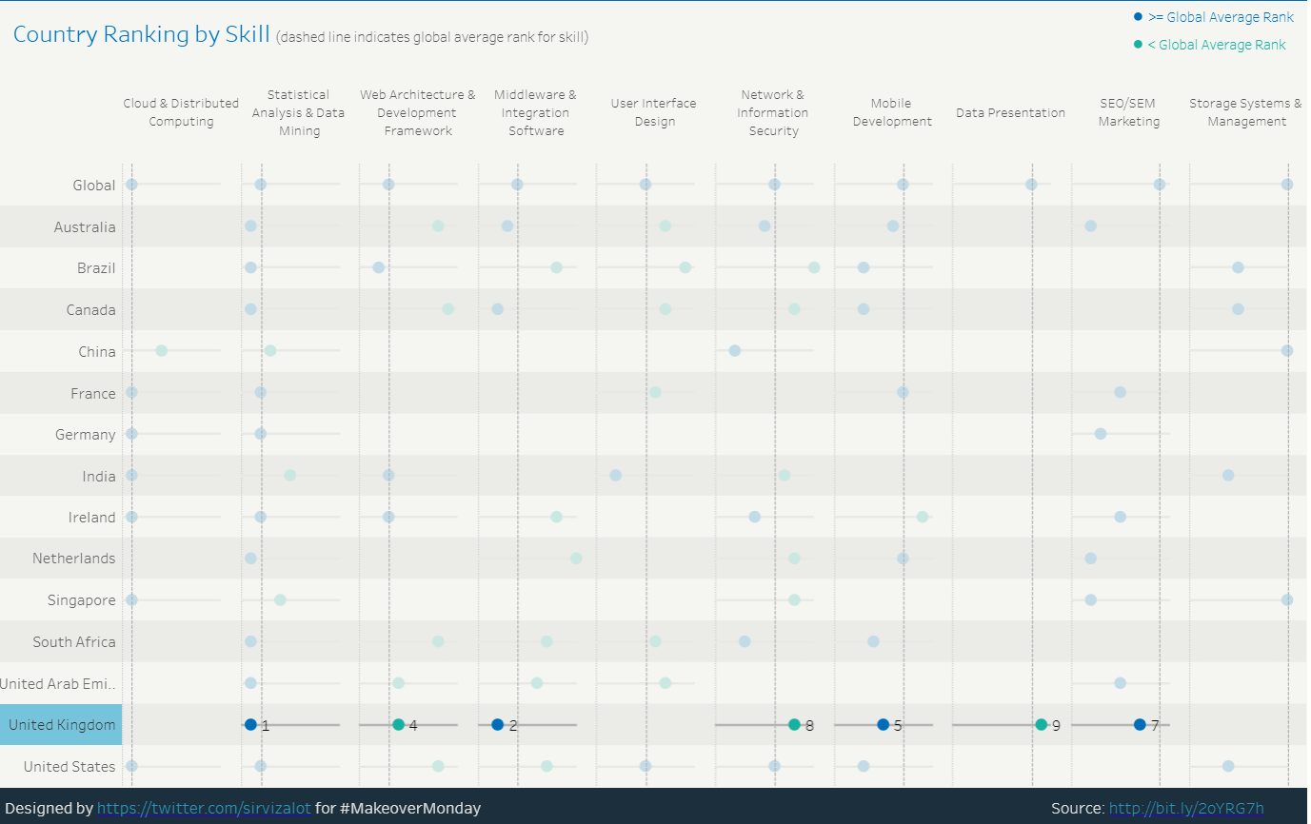

Three skills in United Kingdom, are below their Global average ranking. See table below

|  |  |  |  |
| --- | --- | --- | --- |
| No | Skill | Global Average Rank | Average rank in United Kingdom |
| 1 | Web Architecture & Development Framework | 3 | 4 |
| 2 | Network & Information Security | 6 | 8 |
| 3 | Data Presentation | 8 | 9 |

The Key on the screenshot shows that green markers indicate that the average ranking for that country and skill, is lesser than the Global average rank, while the blue markers show that the average ranking for that country and skill is greater than or equal to the Global average rank.

I clicked on the Global raw, to see the global average ranking for all skills. I took a screenshot of this.

I then clicked on United Kingdom, to see the ranking for skills present in this country.

I then used the Key to find the Skills whose average is below their respective Global Average Ranking